

**KABARAK UNIVERSITY**

**SCHOOL OF SCIENCE ENGINEERING AND TECHNOLOGY**

**DEPARTMENTY OF COMPUTER SCIENCE AND IT**

PROJECT

PROJECT TITTLE:

E-DIARY APPLICATION WITH A TO-DO LIST CHECKMARK

**A Project Report Documentation Submitted in The Department of Computer Science and IT in partial fulfillment of the degree of Information Technology**.

**SUBMITTED BY:**

Name of Student: KELVIN MBURU Registration Number: INTE/MG/2983/09/18

**SUPERVISOR:**

MR. CLEOPHAS MOCHOGE

**MAY-AUG 2024**

Submitted On:___/08/2024

# **DECLARATION**

I hereby declare this project is based on my original work except for reference and quotations which have been duly acknowledged. I also declare that this has not previously or currently been submitted for any other degree or award at Kabarak University.

Signature ……………………………………………………

# **RECOMMENDATION**

I the supervisor do hereby certify that this is a true report for the project undertaken by the above-named student under my supervision and that it has been submitted to Kabarak University with my approval.

Signature …………………………………

Date …………………………………

# **ACKNOWLEDGEMENT**

First and foremost, my deepest gratitude goes to Almighty God who is the source of strength, knowledge and wisdom. Secondly, I wish to appreciate my family and friends as they consistently supported me through this project. I would also like to show my appreciation to the Kabarak University library staff for the good services they offered me to ensure smooth work in terms of library resources, that is, stable internet connection and reading materials. Lastly, my appreciation goes to my supervisor for challenging me to perfect my project and for rectifying me in areas that needed corrections.

# **DEDICATION**

This work is dedicated to my parents who have been the main source of spiritual, emotional and financial support. For them they have been a good inspiration as far as the academic journey is concerned.

Secondly my dedication goes to my lectures they have added a lot of positive impact to my life in terms of knowledge and skills I have gotten from classes.

# **ABSTRACT**

In today's fast-paced world, individuals face challenges in managing their time and staying organized, which can lead to decreased productivity and increased stress. The traditional paper-based diary or journal may no longer be convenient or accessible for modern users who prefer digital platforms. This led to a growing need for a user-friendly and efficient e-diary application with a to-do list that can support individuals in managing their daily activities and improving their mental health and well-being. This project aimed to develop an e-diary application with a to-do list and evaluate its usability and effectiveness in supporting users to manage their time and achieve their goals. The study was significant because it addresses a growing need for digital tools that can help people to stay organized and manage their time more efficiently, while also offering potential benefits for mental health and well-being. The key features required for an effective e-diary application with a to-do list have been identified, which can contribute to the development of more user-friendly and effective digital tools for time management and productivity. The study also evaluate the potential limitations and challenges associated with developing and implementing an e-diary application with a to-do list, such as user adoption, technological constraints, privacy and security concerns, customization limitations, and cost. Overall, this project seeks to address the problem of time management and organization by providing a practical and user-friendly digital solution that can support individuals in managing their daily activities and improving their overall well-being.

Contents

**DECLARATION** ii

**RECOMMENDATION** iii

**ACKNOWLEDGEMENT** iv

**DEDICATION** v

**ABSTRACT** vi

**CHAPTER ONE** 1

**INTRODUCTION** 1

1.0 INTRODUCTION 1

1.1 BACKGROUND OF STUDY 1

1.2 PROBLEM STATEMENT 2

1.3 PURPOSE OF STUDY 3

1.4 RESEARCH OBJECTIVE 3

1.5 SPECIFIC OBJECTIVES 3

1.6 RESEARCH QUESTIONS 3

1.7 SIGNIFICANCE OF STUDY 4

1.8 LIMITATIONS 4

**CHAPTER TWO** 5

**LITERATURE REVIEW** 5

2.0 INTRODUCTION 5

2.1 TRADITIONAL PAPER BASED DIARIES 5

2.2 DESIGN AND USABILITY OF E-DIARIES 5

2.3 FACTORS INFLUENCING ADOPTION 6

2.4 E-DIARIES IN HEALTH AND BEHAVIORAL RESEARCH 6

2.5 BENEFITS AND CHALLENGES 6

2.6 Conclusion 7

**CHAPTER THREE** 8

**METHODOLOGY** 8

3.0 INTRODUCTION 8

3.1 SYSTEM DEVELOPMENT METHODOLOGY 8

3.2 PROGRAMMING METHODOLOGY 10

3.3 RESEARCH DESIGN 10

3.4 LOCATION OF STUDY 11

3.5 POPULATION OF STUDY 12

3.6 SAMPLING PROCEDURE AND SAMPLE SIZE 13

3.6.1 SAMPLING PROCEDURE 13

3.6.2 SAMPLE SIZE 14

3.7 DATA COLLECTION PROCEDURES 14

3.7.1 SURVEY QUESTIONNAIRE 15

3.7.2 SEMI-STRUCTERED INTERVIEWS 15

3.7.3 DATA ANALYSIS 16

3.7.4 ETHICAL CONSIDERATIONS 16

3.8 SYSTEM ANALYSIS AND DESIGN 17

3.8.1 CONTEXT DIAGRAM 17

3.8.2 USE CASE DIAGRAM 18

3.8.3 DFD DIAGRAM 19

3.8.4 ACTIVITY DIAGRAM 20

**CHAPTER FOUR** 21

**SYSTEM DEVELOPMENT AND DEPLOYMENT** 21

4.1 SYSTEM DESCRIPTION AND DEPLOYMENT 21

4.2 SYSTEM CODE AND DESIGN 22

4.3 SYSTEM TESTING 32

4.3.1 UNIT TESTING 32

4.3.2 INTEGRAL TESTING 32

**CHAPTER FIVE** 34

**CONCLUSSION AND RECOMMENDATION** 34

5.1 CONCLUSION 34

5.2 RECOMMENDATION 35

5.3 SUMMARY 35

REFERENCES 36

APPENDICES 37

Appendix I: Research Instruments 37

Appendix II: Work Plan 37

Appendix III: Budget 38

**LIST OF FIGURES**

Figure 1: Agile Development Lifecycle 9

Table 1: Sample Size Calculation 14

Figure 2:Context Diagram 17

Figure 3:Use Case Diagram 18

Figure 4::DFD-01 diagram 19

Figure 5: Activity Diagram 20

Figure 6:Website homepage 23

Figure 7: Registration Form 24

Figure 8: Registration Code 24

Figure 9: Sign-In Form 25

Figure 10: Sign-In code 25

Figure 11: User Homepage 26

Figure 12: Manage categories 27

Figure 13:Manage Notes Form 28

Figure 14:To-do list homepage. 28

Figure 15: Adding Task on To-do list 29

Figure 16: Update To-Do List 30

Figure 17:System Database Form 31

Figure 18:database model code 31

Table 2: Unit Testing 32

Table 3: Integration Testing 32

Table 4: Acceptance Testing 33

# **CHAPTER ONE**

# **INTRODUCTION**

## INTRODUCTION

In today's fast-paced world, it has become increasingly difficult for people to stay organized and manage their time effectively. With the rise of digital technology, people have been looking for tools that can help them manage their daily activities and stay productive. The e-diary application with a to-do list is one such digital tool that provides a convenient and efficient way for individuals to keep track of their daily tasks and activities.

## 1.1 BACKGROUND OF STUDY

The use of digital tools for productivity and time management became increasingly popular in recent years. With the advent of remote work and the increasing reliance on technology, people have been searching for ways to stay organized and manage their time efficiently. One such digital tool is the e-diary application with a to-do list, which provides a digital platform for individuals to record their daily activities and manage their to-do lists.

In addition, research has shown that keeping a diary or journal can have numerous benefits for mental health and well-being. Recording one's thoughts and emotions has helped individuals to process their experiences and gain a better understanding of their feelings. In addition, having a clear record of daily activities and accomplishments has helped individuals to feel a sense of progress and accomplishment, which has improved overall well-being and motivation.

In today's fast-paced world, individuals have faced challenges in managing their time and staying organized. The traditional paper-based diary or journal used to be a popular tool for many years, but it is no longer convenient or accessible for modern users who prefer digital platforms. In recent years, there has been an increasing need for an efficient and user-friendly e-diary application with a to-do list that can support individuals in managing their daily activities and improving their mental health and well-being.

The limitations of traditional paper-based diaries and journals included the lack of customization options, limited mobility, and the risk of losing important information. Furthermore, traditional paper-based diaries are not able to offer the same level of organization and productivity as digital platforms, which made it challenging for individuals to manage their time effectively.

Existing digital tools for time management and productivity include applications such as calendars, to-do lists, and note-taking apps. However, these tools can often be complex and difficult to use, especially for individuals who are not technologically proficient. Some of these tools also lack essential features, such as the ability to track progress, set reminders, or prioritize tasks.

Moreover, some digital tools do not offer the benefits of traditional paper-based diaries, such as the ability to reflect on and process emotions. This was a critical aspect as emotional regulation and self-reflection play an important role in mental health and well-being.

Therefore, there had been a growing need for an e-diary application with a to-do list that could combine the benefits of traditional paper-based diaries with the convenience and flexibility of digital platforms. The application provides a user-friendly interface, customization options, and features that support time management and productivity, while also promoting mental health and well-being.

The purpose of this study was to develop an e-diary application with a to-do list that could meet the diverse needs of its users, while also offering the benefits of traditional paper-based diaries. The study aimed to identify the key features required for an effective e-diary application, evaluate its usability and effectiveness, and explore its potential limitations and challenges.

The significance of this study lied in its potential to provide a practical and user-friendly digital solution that could support individuals in managing their daily activities and improving their overall well-being. By addressing the limitations of traditional paper-based diaries and existing digital tools, this study contributed to the development of more effective and accessible digital tools for time management and productivity.

## 1.2 PROBLEM STATEMENT

The traditional method of using paper diaries and to-do lists to keep track of daily activities became outdated and inefficient in the modern age. The lack of a centralized system for recording and managing daily tasks led to disorganization, missed appointments, and forgotten deadlines. This problem affected people from all walks of life, including students, professionals, and individuals who needed to manage their personal lives effectively. It also had environmental consequences due to the overuse of paper. This problem was further exacerbated by the need to carry the paper diary and to-do list everywhere, which was inconvenient, especially when one forgot to bring them along.

## 1.3 PURPOSE OF STUDY

The purpose of this study was to design and develop an e-diary application with a to-do list feature to help users record their daily activities and manage their time more efficiently. The study aimed to provide a user-friendly and efficient digital platform that could support individuals in achieving their daily goals and improving their well-being.

## 1.4 RESEARCH OBJECTIVE

The general objective of this document was to develop and evaluate an e-diary application with a to-do list that could meet the diverse needs of its users, while also offering the benefits of traditional paper-based diaries, and to identify potential limitations and challenges associated with its development and implementation.

## 1.5 SPECIFIC OBJECTIVES

To achieve the purpose of the study, the following specific objectives were identified:

1. To identify the key features required for an effective e-diary application with a to-do list.
2. To design and develop a user-friendly e-diary application.
3. To evaluate the usability and effectiveness of the e-diary application in supporting users to manage their time and improve their well-being.

## 1.6 RESEARCH QUESTIONS

To achieve the above research objectives, the following research questions were formulated:

1. What were the key features required for an effective e-diary application with a to-do list?
2. How can a user-friendly e-diary application be designed and developed?
3. What is the usability and effectiveness of the e-diary application with a to-do list in supporting users to manage their time and improve their well-being?

## 1.7 SIGNIFICANCE OF STUDY

The e-diary application with a to-do list can help individuals to stay organized and manage their time more efficiently, leading to increased productivity and improved well-being. The study contributed to the development of digital tool that supported mental health and well-being, offering a convenient and effective way for individuals to record their thoughts and emotions. Furthermore, the study provided insights into the design and development of user-friendly and effective digital platform that met the needs of modern users.

## 1.8 LIMITATIONS

There were several potential limitations considered in the development and implementation of an e-diary application. Some of these limitations included:

1. User adoption: Even with a well-designed and user-friendly application, there was no guarantee that users would adopt it. Users may already have established habits for managing their time or prefer alternative tools, and could not see the value in switching to a new digital platform.
2. Cost: Developing, maintaining, and updating an e-diary application with a to-do list could have been costly, and may have required a significant investment of time and resources. If the costs associated with developing and maintaining the application were too high, it could not have been financially sustainable in the long term.

# **CHAPTER TWO**

# **LITERATURE REVIEW**

## INTRODUCTION

Electronic diaries (e-diaries) with to-do list functionality are gaining traction in both personal and professional domains due to their convenience and efficiency. These digital tools not only help in documenting daily activities and reflections but also incorporate features like checkmarks for tasks, which enhance productivity and organization. This literature review explores the design, usability, and factors influencing the adoption of e-diaries with to-do lists while also offering the benefits of traditional paper based diaries, drawing on from recent scholarly research.

## 2.1 TRADITIONAL PAPER BASED DIARIES

One of the main benefits of paper-based diaries is their accessibility. This simplicity can be particularly advantageous for older adults or individuals in low-resource settings. (Stone et al. 2002) note that the physical act of writing can also aid memory and cognitive processing, which may enhance the accuracy of self-reported data.

Paper diaries offer a tangible and personal medium for expression. The physical nature of paper allows users to personalize their diaries with drawings, notes, and other creative elements, which can enhance emotional engagement and satisfaction. According to (Bolton et al. 2013), the act of writing in a physical diary provide a sense of ownership and attachment.

Paper-based diaries has the ability to promote emotional regulation and well-being. Writing down one's emotions and experiences can be cathartic, allowing individuals to process their emotions and gain insight into their thoughts and behaviors. Studies have shown that expressive writing, such as keeping a diary, can reduce stress and anxiety, promote positive mood, and improve overall well-being (Baikie & Wilhelm, 2005).

The downside to paper-based diaries is that they are often associated with lower data quality and compliance compared to electronic diaries. Participants may forget to make entries or backfill data, leading to inaccuracies. (Stone et al. 2003) found that compliance rates with paper diaries are generally lower, and the potential for recall bias is higher compared to electronic diaries.

## 2.2 DESIGN AND USABILITY OF E-DIARIES

The design of e-diaries significantly impacts their usability and user engagement. Key elements include intuitive interfaces, customizable features, and integration with other digital tools. A study by (Daniels et al., 2021) highlighted that attractive design, clear data visualization, and reminders are crucial for effective use in healthcare settings. These features ensure that users can easily navigate the diary, visualize their progress, and stay motivated through reminders and notifications.

Moreover, research indicates that the choice of design elements should be informed by user preferences and specific use cases. For instance, a qualitative study by BMC Medical Research Methodology (2021); (Janssens et al., 2018) pointed out that the design of e-diaries should balance between fixed and random assessments, and momentary versus retrospective data collection, depending on the study's objectives and the nature of the data being collected.

## 2.3 FACTORS INFLUENCING ADOPTION

Several factors influence the adoption and sustained use of e-diaries. According to (Daniëls et al. 2021), these factors can be categorized into user characteristics, intervention features, and implementation processes. User characteristics such as familiarity with smartphones, intrinsic motivation, and educational background play a significant role in determining how effectively individuals use e-diaries.

The intervention features include the technical aspects of the diary, such as ease of use, data security, and the ability to personalize settings. Implementation processes encompass the training and support provided to users, which are critical for ensuring that they can effectively utilize the diary's features. Without adequate training, users may struggle to leverage the full potential of e-diaries.

## 2.4 E-DIARIES IN HEALTH AND BEHAVIORAL RESEARCH

E-diaries are extensively used in health and behavioral research to collect real-time data on participants' activities, emotions, and physiological responses. A scoping review by PubMed (2021) emphasized that e-diaries are particularly useful in capturing momentary data that traditional paper diaries cannot. This real-time data collection helps in obtaining accurate and reliable information, which is essential for clinical studies and psychological research.

Furthermore, according to PubMed(2021) e-diaries with to-do list functionalities are beneficial in managing chronic conditions and supporting behavioral interventions. For example, they can help patients with diabetes track their daily activities, medication adherence, and dietary habits, thereby facilitating better self-management and improved health outcomes.

Shiffman et al. (2008) highlight the advantages of e-diaries in ecological momentary assessment (EMA), where data are collected in real-time and in the participant's natural environment, reducing recall bias and increasing the ecological validity of the data.

## 2.5 BENEFITS AND CHALLENGES

The primary benefits of using e-diaries with to-do lists include enhanced organization, improved time management, and increased accountability. Users can prioritize tasks, set reminders, and mark completed tasks, which helps in maintaining a clear overview of their responsibilities and progress.

E-diaries are utilized in educational settings for self-assessment and reflective learning. They allow students to track their learning progress, set goals, and reflect on their experiences. A study by Yan et al. (2019) found that e-diaries enhance self-regulation and motivation among students, leading to improved academic performance.

E-diaries also improve data accuracy and compliance. Electronic reminders and automated data entry reduce the likelihood of missing entries and enhance the precision of the recorded information. (Tiplady et al. 1995) demonstrated that the use of handheld electronic diaries in clinical trials resulted in higher compliance rates and more accurate data compared to paper diaries.

E-diaries are designed to be user-friendly and engaging. The interactive nature of these tools encourages regular use and helps maintain user motivation. Hufford (2007) emphasizes that features such as customizable interfaces and real-time feedback contribute to higher user engagement and satisfaction.

However, challenges such as technical issues, user resistance, and privacy concerns need to be addressed. As noted in the BMC study (Janssens et al., 2018), occasional technical difficulties like battery life and software malfunctions can hinder the effective use of e-diaries. Additionally, ensuring data security and protecting user privacy are critical to gaining user trust and widespread adoption.

## 2.6 Conclusion

E-diaries with to-do list checkmarks offer numerous benefits for personal productivity and health management. Their design and usability are crucial for user engagement, and several factors influence their adoption. While they present significant advantages, addressing challenges related to technical reliability and privacy is essential for their sustained use. Continued research and development in this field will likely yield even more sophisticated and user-friendly tools in the future.

# **CHAPTER THREE**

# **METHODOLOGY**

## 3.0 INTRODUCTION

This chapter focused on the methodology that was used to investigate the effectiveness of an e-diary with a to-do list feature. The chapter begins with an overview of the system development methodology then research design, followed by a description of the data collection methods and data analysis techniques that were used. Finally, the chapter discussed the ethical considerations that were taken into account throughout the research process.

The primary objective of this research was to determine if the inclusion of a to-do list feature in an e-diary would result in improved user satisfaction and increased use of the diary. This research aimed to investigate the perceptions and experiences of users when using an e-diary with a to-do list feature compared to a traditional paper diary.

The methodology employed in this study was chosen based on the research questions and the purpose of the study. The research design aimed to capture the opinions and experiences of users by conducting surveys and interviews. The survey aimed to collect quantitative data, while the interviews aimed to gather qualitative data.

This chapter provides a detailed explanation of the methodology used in this research project. It discusses the sampling procedure, data collection method, and data analysis techniques used to investigate the effectiveness of an e-diary with a to-do list feature. The methodology employed in this study was essential in ensuring the validity and reliability of the research findings.

## 3.1 SYSTEM DEVELOPMENT METHODOLOGY

For the development of the e-diary application with to-do list, the Agile methodology was used. Agile is a flexible and iterative approach to software development that allows for frequent collaboration and feedback between the development team and stakeholders. It is well-suited for projects where requirements are likely to change, and where it is important to be able to respond quickly to those changes. The Agile methodology is characterized by a series of short iterations, typically lasting two to four weeks. Each iteration involves planning, designing, building, testing, and deploying a working increment of the software. At the end of each iteration, the development team and stakeholders review the progress and decide on the next set of features to be implemented.

The Agile methodology was well-suited to the development of the e-diary application with to-do list, as it allowed for frequent feedback and collaboration between the development team and users. This helped to ensure that the application met the needs of its users and was well-designed and easy to use. Additionally, the Agile methodology allowed for flexibility in the face of changing requirements or unexpected challenges, which remains important in a fast-paced and rapidly-changing technology environment.

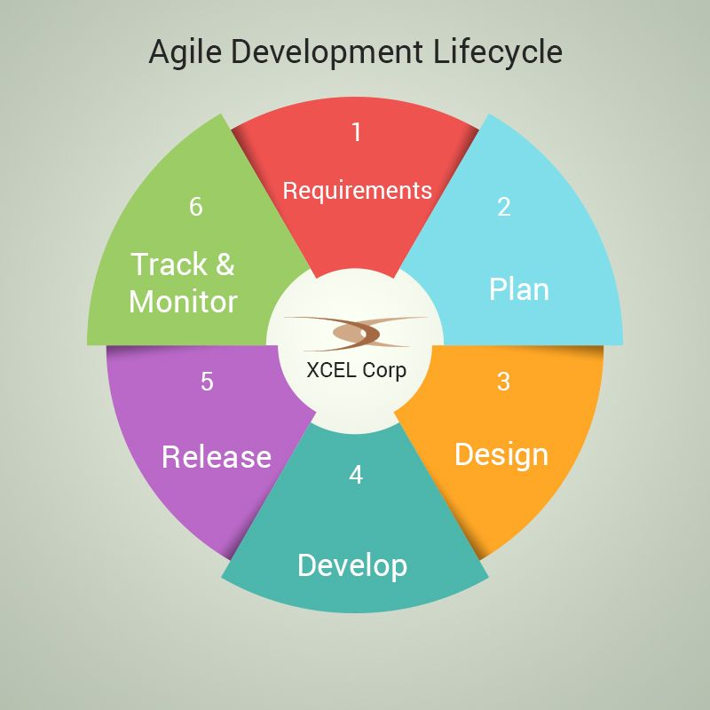

Figure : Agile Development Lifecycle

## 3.2 PROGRAMMING METHODOLOGY

For this project, I used the following programming methodologies and software to achieve the objectives:

1. Front-end development: I used HTML, CSS, and JavaScript to create the user interface of the e-diary application with a to-do list feature.
2. Back-end development: I used Python and its web framework, Django, to build the back-end of the application.
3. Database: I used SQLITE3 as my database management system to store user data and to-do list items.
4. Version control: I used Git for version control and collaboration with my team members.
5. Integrated Development Environment (IDE): I used Visual Studio Code as IDE for Python development.
6. Testing: I used PyTest for testing the code and ensuring that it met the project's requirements and objectives.

Overall, this programming methodology was designed to ensure efficient and effective development of the e-diary application with a to-do list feature, while maintaining the highest standards of code quality and security.

## 3.3 RESEARCH DESIGN

Designing a research study that involved an e-diary with a to-do list required careful planning and consideration. Here are some key considerations:

1. Study design: This study used a within-subjects design, where participants completed the study tasks on both the e-diary with a to-do list and a paper diary without the to-do list. The order of the two conditions was counterbalanced across participants.
2. Participants: Participants were recruited from the general population, aged 18 years and older, who had access to a smartphone or computer. A sample size of at least 40 participants was desired to provide adequate statistical power.
3. Informed consent: Participants were provided with information about the study and asked to provide informed consent before participating.
4. Study tasks: Participants were asked to complete a series of diary entries over a two-week period. Each day, participants were asked to record their mood, level of stress, and productivity using both the e-diary with a to-do list and a paper diary without the to-do list.
5. Data collection: Data was collected using an online survey platform, such as Qualtrics and SurveyMonkey. Participants were asked to complete the surveys at the end of each day. Data was collected on the frequency of completed to-do list items and the impact of using the to-do list on mood, stress, and productivity.
6. Data analysis: The data was analyzed using repeated measures ANOVA(Analysis of Variance) to investigate differences between the e-diary with a to-do list and the paper diary without the to-do list. Additional analyses investigated the relationship between completed to-do list items and mood, stress, and productivity.
7. Ethical considerations: Ethical considerations included ensuring participant confidentiality and data security, as well as obtaining informed consent from participants.

Overall, this research design method allowed for investigating the effectiveness of using an e-diary with a to-do list compared to a paper diary without the to-do list. The within-subjects design allowed for controlling of individual differences between participants, while the use of repeated measures ANOVA allowed for investigating differences in outcomes between the two diary types. The analysis of completed to-do list items allowed for additional insights into the relationship between productivity and mood/stress.

## 3.4 LOCATION OF STUDY

This study was conducted in Kenya, specifically in the metropolitan area of a large city Nakuru. The choice of location was based on the fact that the city had a large population with a high usage of digital devices, including smartphones and computers. In addition, the city has a diverse population with different professions and lifestyles, making it an ideal location to study the use of digital diary applications with to-do list features across different demographics.

Research Sites

The research sites for this study were selected based on the availability of individuals who regularly used digital diary applications. Recruitment of participants was conducted through online platforms, such as social media and email listservs, with the aim of reaching a diverse sample of individuals from different professions and backgrounds. Participants who agreed to participate in the study were asked to complete an online survey and a subset of these participants were invited to participate in a semi-structured interview.

Unique Characteristics of the Site

The city where the study was conducted is known for its fast-paced lifestyle and high-stress environment, making it an ideal location to study the use of digital diary applications with to-do list features as a coping mechanism for managing daily tasks and responsibilities. In addition, the city has a high proportion of individuals who work in creative industries, such as media, advertising, and design, which may influence the way they use digital diary applications to manage their tasks and workflow. Finally, the city has a high level of technological adoption, with a large proportion of the population using digital devices and applications on a daily basis. These unique characteristics of the study site provided valuable insights into the use of digital diary applications with to-do list features in a high-stress, fast-paced, and technologically advanced environment.

## 3.5 POPULATION OF STUDY

The population for this study included individuals who used digital diary applications on their smartphones or computers. The target population for this study was individuals who were at least 18 years of age and reside in Kenya, specifically in the metropolitan area of the selected city Nakuru.

The accessible population for this study was individuals who were active users of digital diary applications, and who were willing to participate in the study. The sample for this study was recruited through online platforms, such as social media and email listservs. The recruitment process was designed to reach a diverse sample of individuals from different professions, age groups, and backgrounds.

The choice of the target population was based on the fact that the use of digital diary applications was widespread among individuals who own smartphones and computers. According to a report by the Pew Research Center, as of 2021, approximately 85% of adults own a smartphone and 77% own a computer, making it a suitable population for this study (Pew Research Center, 2021). Additionally, the selected city has a diverse population with different professions and lifestyles, which will enable the research to capture a wide range of perspectives on the use of digital diary applications with to-do list features.

The sample size for this study was determined using a purposive sampling technique, and was based on the saturation point, where no new information or themes emerged from the data. The sample size was large enough to ensure that the findings were representative of the targeted population and have sufficient power to identify significant patterns and themes in the data.

## 3.6 SAMPLING PROCEDURE AND SAMPLE SIZE

## 3.6.1 SAMPLING PROCEDURE

The sampling procedure for this study was purposive, as it aimed to recruit individuals who were active users of digital diary applications with to-do list features and who were willing to participate in the study.

The recruitment process was conducted online, through social media platforms such as Facebook, Twitter, and LinkedIn. In addition, email listservs and professional networking websites were used to reach out to potential participants.

Participants were recruited using a snowball sampling technique, where existing participants were asked to refer other potential participants who met the inclusion criteria. This approach helped to ensure a diverse sample of individuals with different backgrounds and experiences. Interested individuals were screened for eligibility. Eligibility criteria included age, access to a smartphone or computer, and willingness to complete diary entries for two weeks. Eligible participants were provided with a consent form and asked to provide informed consent before participating in the study.

The final sample size was determined based on the saturation point, where no new information or themes emerged from the data. Data collection continued until the research team was confident that they had achieved a comprehensive understanding of the research problem and had captured diverse perspectives on the use of digital diary applications with to-do list features.

## 3.6.2 SAMPLE SIZE

Based on the purposive sampling approach and the saturation point criterion, the sample size for this study was approximately 60 participants.

The accessible population for this study consisted of individuals who were active users of digital diary applications. However, since this was a qualitative study and not designed to produce generalizable results, the focus was on achieving depth of understanding and not repetitiveness.

The final sample size was determined based on the saturation point criterion, where data collection continued until the research team was confident that they had achieved a comprehensive understanding of the research problem and had captured diverse perspectives on the use of digital diary applications with to-do list features.

There was no formal categories of target population as the focus was on recruiting participants who met the inclusion criteria and could provide rich insights into the research problem.

|  |  |  |
| --- | --- | --- |
| **Criterion** | **Calculation** | **Result** |
| Saturation point | Data collection until no new information or themes emerge | 60 |
| Total number of surveys | N/A | 60 |

Table : Sample Size Calculation

Note: The saturation point criterion was determined based on a review of existing literature on sample sizes in qualitative research and consultation with the research team.

## 3.7 DATA COLLECTION PROCEDURES

The data collection procedure for this study involved gathering baseline measures of diary use, including frequency, length, and content of diary entries from participants before randomly assigning them to use either the e-diary with a to-do list or a paper diary without the to-do list for the first week of the study. Participants then completed daily diary entries for two weeks, using either the e-diary or paper diary depending on their assigned condition. They were instructed to write about their daily activities and experiences, as well as to use the to-do list feature if they were using the e-diary. After two weeks, they were asked to complete a post-test questionnaire that measured their satisfaction with the diary system and perceptions of the to-do list feature. Data collected from the pre- and post-tests were analyzed using descriptive and inferential statistics to examine changes in diary use and perceptions of the diary system over time.

## 3.7.1 SURVEY QUESTIONNAIRE

The survey questionnaire used in this study was developed based on the research objectives and research questions. Some sample survey questions that were used for the e-diary application with to-do list project included:

1. How often do you currently use a diary or planner to keep track of your daily tasks and activities?
2. What types of tasks do you typically include in your to-do list?
3. How satisfied are you with your current method of managing your daily tasks and activities?
4. Have you ever used an electronic diary or planner application before? If so, which one(s) and what features did you find most useful?
5. What features would you like to see in an electronic diary application with to-do list?
6. How frequently do you think you would use an electronic diary application with to-do list?
7. How important is it for you to have a mobile app version of the electronic diary application?
8. How comfortable are you with sharing your personal data (e.g. name, email address) when signing up for an electronic diary application?
9. How important is data security to you when using an electronic diary application with to-do list ?
10. How likely are you to recommend the electronic diary application with to-do list to others?

## 3.7.2 SEMI-STRUCTERED INTERVIEWS

The purpose of the interviews was to gather more in-depth and nuanced information about participants' experiences and opinions regarding the use of an e-diary application with a to-do list feature.

The interview questions were designed to explore participants' motivations for using an e-diary application, their experiences with the application, and their perceptions of the benefits and drawbacks of using a to-do list feature. The questions were open-ended and allowed participants to share their experiences and opinions in their own words.

The interviews were conducted either in person or via video conferencing, depending on participants' preferences and availability. All interviews were audio-recorded and transcribed verbatim for analysis.

## 3.7.3 DATA ANALYSIS

The first step in data analysis was to clean and prepare the data for analysis. This involved checking for missing or erroneous data, removing outliers, and ensuring that the data was in a format that could be easily analyzed. The next step was to calculate descriptive statistics for the data, including measures of central tendency (such as means and medians) and measures of variability (such as standard deviations and ranges). These statistics provided a basic overview of the data and helped identify patterns or trends. The data collected from the e-diary with a to-do list and the paper diary without the to-do list were compared using inferential statistics ANOVA. This helped determine if there were any significant differences in diary use or satisfaction between the two systems.

Correlation analysis was conducted to examine the relationships between different variables in the study, such as the frequency of diary entries and the use of the to-do list feature. This helped identify any patterns or relationships in the data. In addition to quantitative analysis, qualitative analysis was conducted on the open-ended questions in the post-test questionnaire. This involved coding the responses and identifying themes or patterns in the data.

## 3.7.4 ETHICAL CONSIDERATIONS

During the data collection process, ethical considerations were taken into account to ensure that the participants' rights were protected. The following ethical considerations were observed:

1. Informed Consent: Participants were informed about the purpose of the study, the data collection process, and the potential risks and benefits of their participation. They were given the option to decline or withdraw from the study at any time.
2. Confidentiality: All data collected from participants was kept confidential and anonymous. Participants' names and personal information were not to be disclosed in any reports or publications.
3. Data Security: All data collected from participants were stored securely to prevent unauthorized access, use, or disclosure. Only authorized researchers had access to the data.
4. Voluntary Participation: Participation in the study was voluntary, and participants were not be coerced or forced to participate.
5. Debriefing: Participants were debriefed at the end of the study to provide them with a summary of the study's findings and addressed any questions or concerns they may have had.

By adhering to these ethical considerations, this study ensured that the participants' rights were protected, and the data collected was of high quality and integrity.

## 3.8 SYSTEM ANALYSIS AND DESIGN

## 3.8.1 CONTEXT DIAGRAM

Sign up/Log in

Request for any entry

Add & View Entries

Mark item as complete

Display Entries

Confirm item as complete

Access all entries

E-diary system

User

Admin

Figure :Context Diagram

## 3.8.2 USE CASE DIAGRAM

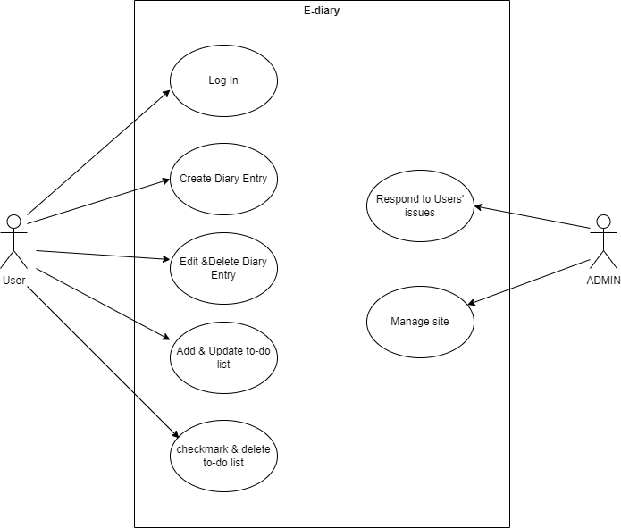

Figure :Use Case Diagram

## 3.8.3 DFD DIAGRAM

Create to do list item

Users’ Database

User Sign up/log in information

Admin log in information

Confirm item added

View to do list item

Display to do list item

Send to do item

Add to do item

Mark item as complete

Confirm item marked as complete

View user’s to do list

Display user’s to do list

Get to do list

Send to do list

Database information

Remove to do item

Request DB information

Manage user’s information

1.0

View To-do List

3.0

To-do List database store

User

Admin

View To-do Items

3.1

Checkmark

4.0

Update or Remove To-do item

4.1

Add To-do Items

2.1

Create To-do List

2.0

Update to do item

Successfully Updated

Display successful log in

Succesful login

Create to do list item

Confirm item added

Successful Remove item

**Access user DB**

Retriee data in user DB

Figure ::DFD-01 diagram

3.8.4 ACTIVITY DIAGRAM

Figure : Activity Diagram

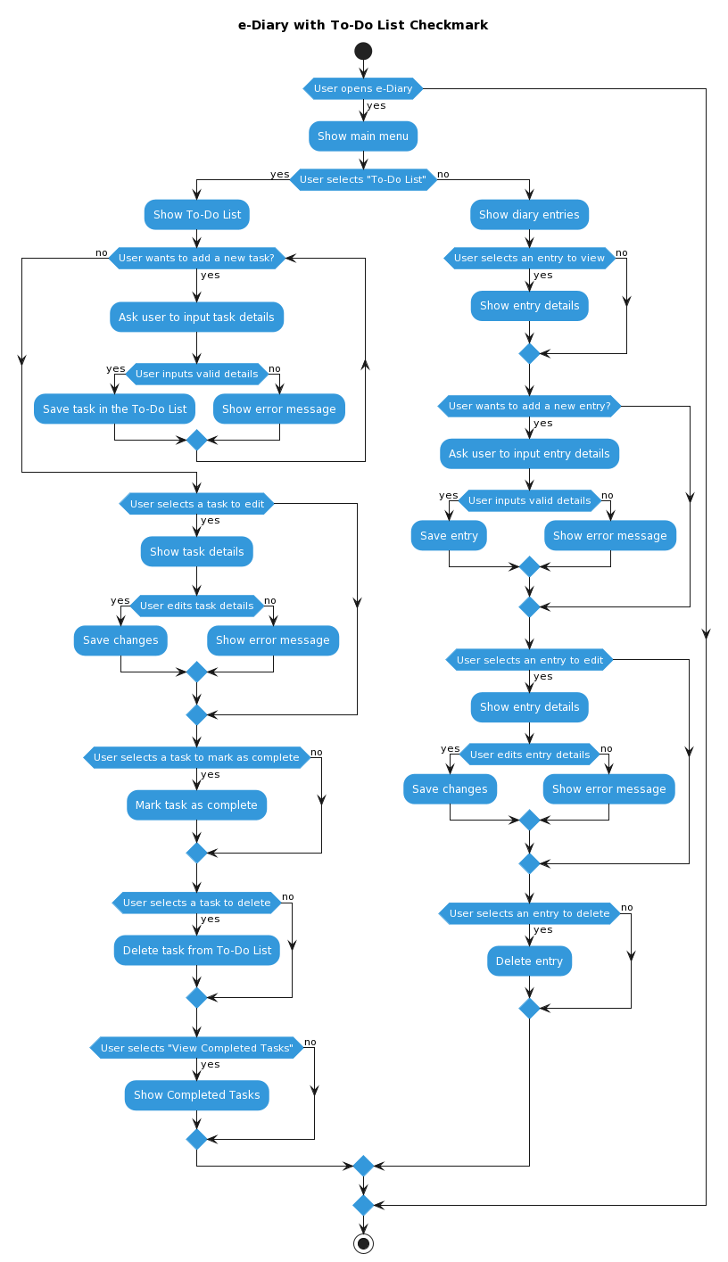

# **CHAPTER FOUR**

# **SYSTEM DEVELOPMENT AND DEPLOYMENT**

## 4.1 SYSTEM DESCRIPTION AND DEPLOYMENT

The e-diary application with a to-do list is a digital tool designed to help users organize their daily activities, record thoughts and emotions, and manage their to-do lists efficiently. The system consists of two main components:

1. **Diary Feature:** This component allows users to create digital diary entries. Users can record their thoughts, emotions, and daily events.
2. **To-Do List Feature:** This feature enables users to create and manage their to-do lists. Users can add, prioritize, and check off tasks as they are completed

Deployment Mechanism:

The deployment mechanism for this project involves taking the developed e-diary application from the development environment to a production environment where it can be used by end-users. Here is an outline of the deployment mechanism:

1. Environment Selection: Choosing a suitable environment for deployment, such as a web server or a cloud platform like AWS or Azure.
2. Configuration Management: Configuring the system for the production environment, setting parameters such as database connections and security settings.
3. Deployment Strategy: Deciding on the deployment strategy, including how often updates and new features will be rolled out to end-users. Continuous deployment or periodic releases will be considered.
4. Testing: Implementing a rigorous testing process to ensure the application functions as expected in the production environment. This includes functional testing, performance testing, and security testing.
5. Monitoring and Maintenance: Setting up monitoring tools to keep an eye on the application's performance and usage. Establish maintenance procedures to address issues and apply updates.
6. Rollback Plan: Developing a plan for rolling back to a previous version in case unexpected issues arise during deployment.
7. Documentation: Maintaining detailed documentation outlining the deployment process to guide team members and troubleshoot problems.
8. Automation: Utilizing automation tools and scripts to streamline the deployment process and minimize the risk of errors.

The specifics of the deployment mechanism can be adapted based on the chosen technology stack and deployment environment. A successful deployment ensures that the e-diary application is accessible to end-users while maintaining its functionality and performance in a live production environment.

## 4.2 SYSTEM CODE AND DESIGN

System design involves planning and structuring the application before the actual coding begins. It encompasses architectural decisions, database schema design, and defining the interaction between different system components.

System code refers to the actual programming and implementation of the software application. It involves writing the source code for the front-end and back-end components of the application.

The screenshots below show the design samples and codes used in the development of e-diary application.

**Website Homepage:**

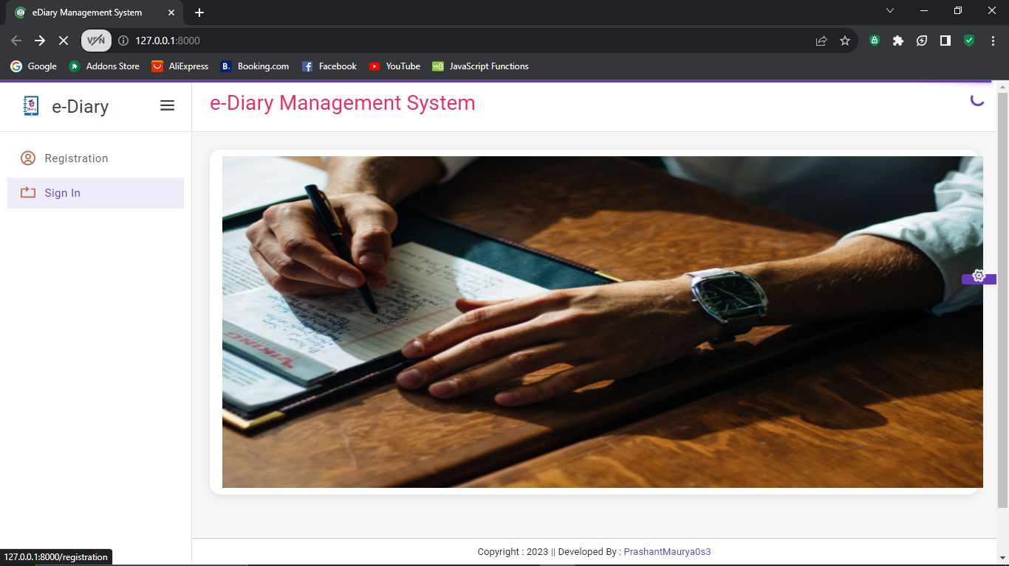

Figure :Website homepage

This is the main page of a website, and it is often the first page that visitors see when they navigate to the e-diary application web address (URL). Under the e-diary menu it contains registration and sign-in button that are used by new and existing users.

**Registration Form:**

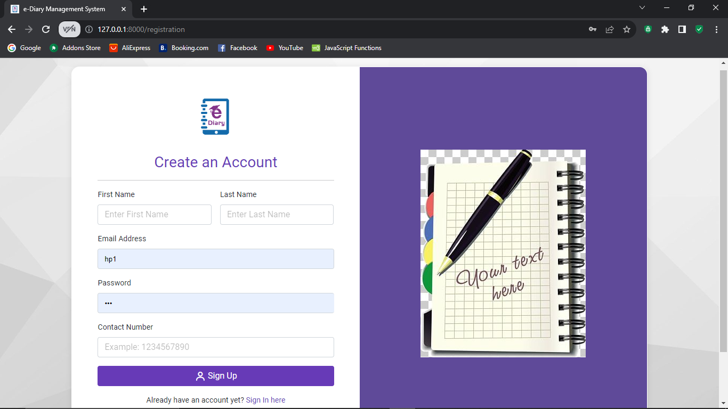

Figure : Registration Form

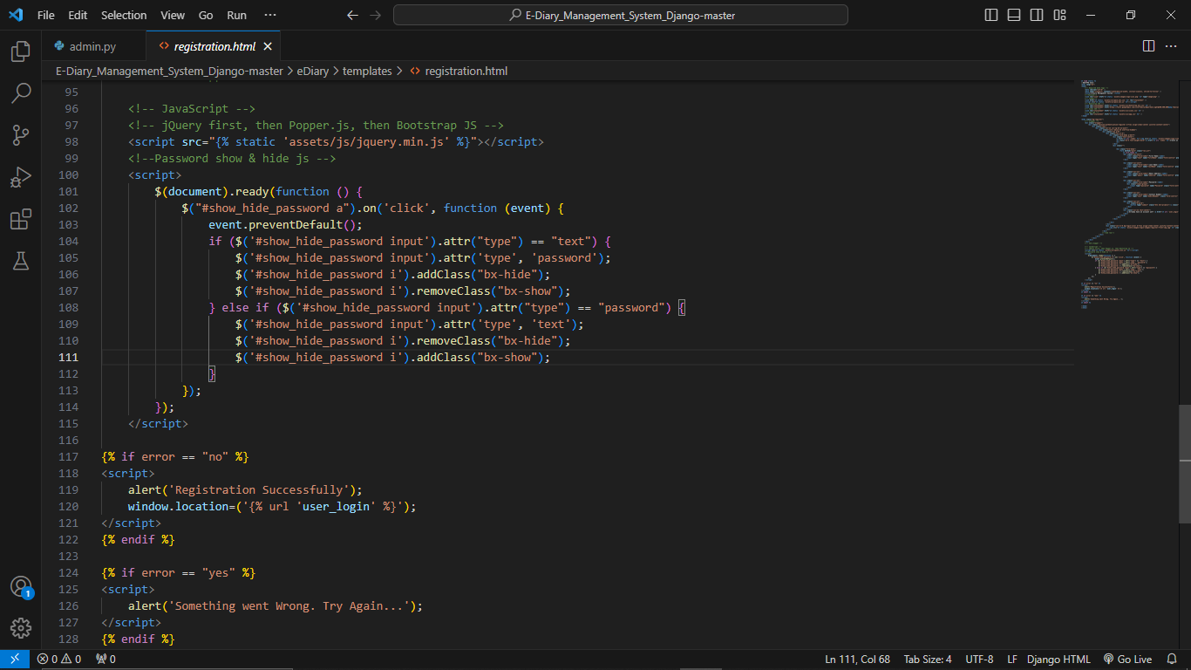

Figure : Registration Code

The above two registration screenshots represent the front-end of user application and the code used to make the form. The code section above generates the registration form where a new user can add his personal details in order to access the e-diary application.

**User login:**

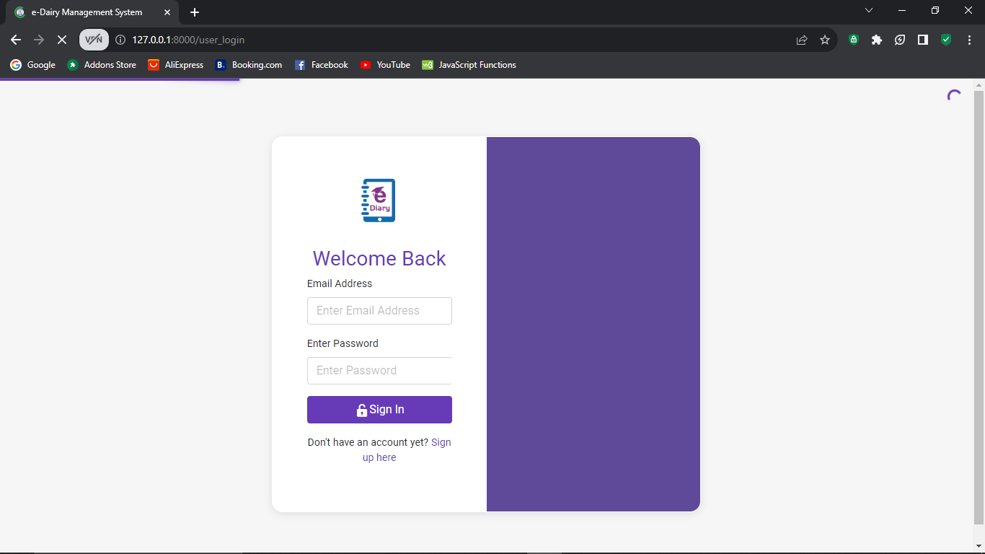

Figure : Sign-In Form

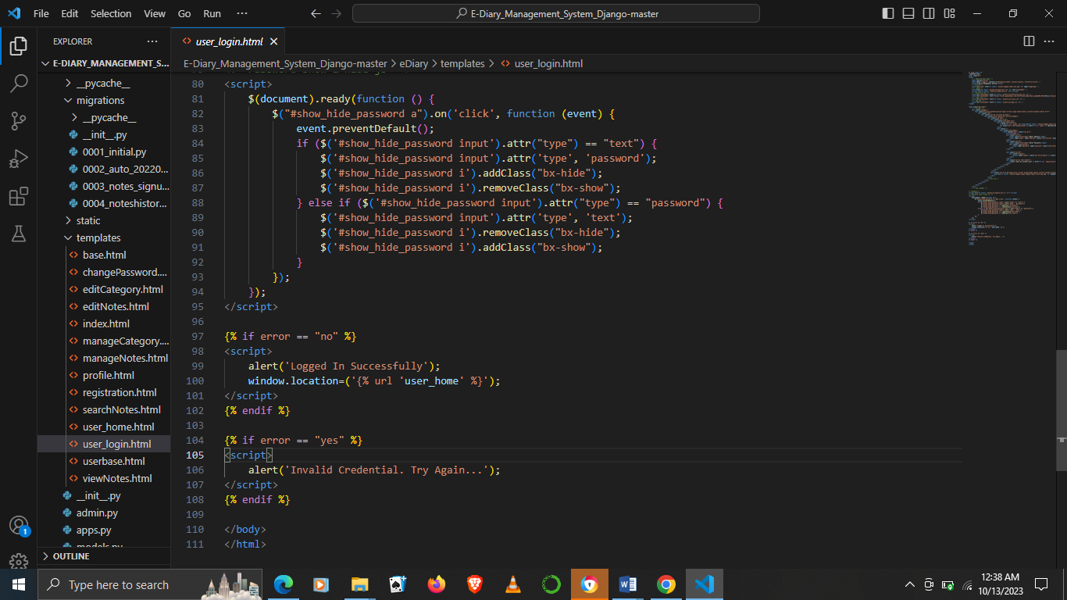

Figure : Sign-In code

For users who exist in the system they proceed to sign-in where their credentials are authenticated before accessing the e-diary system. The above code is what generates the sign-in form.

**User homepage:**

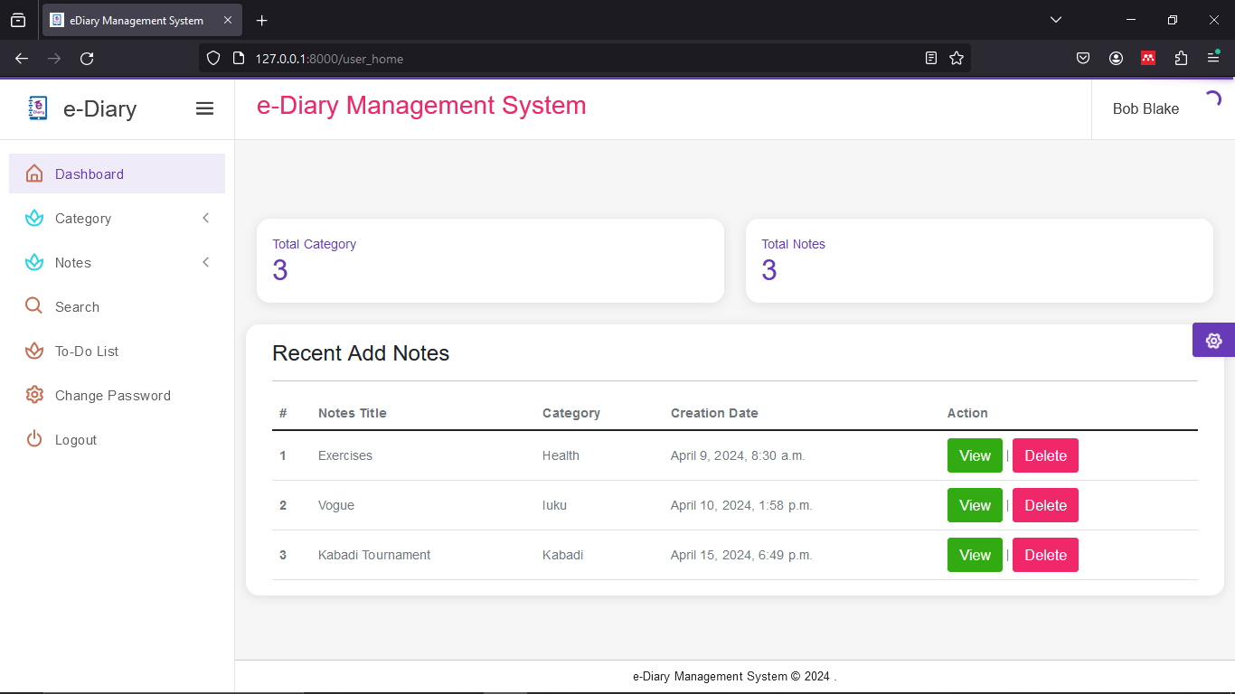

Figure : User Homepage

After logging in the system, a user is presented with the above homepage. Here the users are able to see their total number of notes created and also recently added notes. They are also provided with a menu that has a list of links to various section of the e-diary system where users can view, add, delete and search for notes. Within the menu a user is also provided with an option of changing his password or logging out of the system once done. Since the application is an e-diary with to-do list, the user can click on the to-do list hyperlink that is within the menu, which will direct him to the to-do list section in order to create, update, delete or complete tasks.

**Manage categories:**

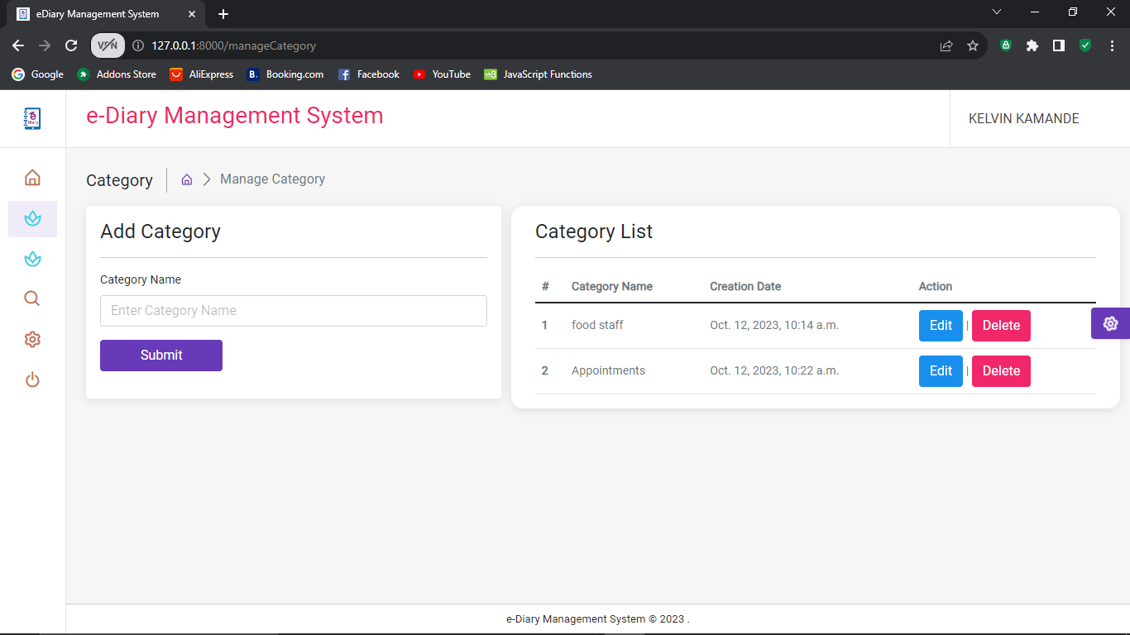

Figure : Manage categories

From the menu provided at user homepage, there is a mange categories command that a user can click in order to access the manage categories form. Here a user can add, view, edit or delete categories of notes. The category section enables a user to group some of similar diary entries under a broad classification. Example: a user can term a category HEALTH, and under that category he can add entries concerning his diet, exercises done, mental state e.t.c

**Manage Notes:**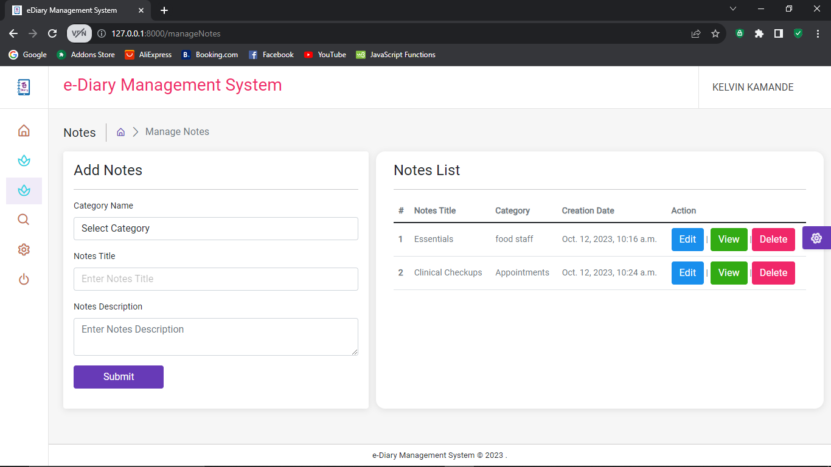

Figure :Manage Notes Form

Here the user is able to add notes title and description of notes. The notes are diary entries that are linked to the category section in order to smoothen easy access of notes and make the system more user friendly. In this form, a user can also view his notes list and he can edit, view and delete notes/diary enrties.

**To-do List:**

The to-do list is designed to help users organize tasks that will occur at some point in the future efficiently and stay on top of their responsibilities. With an intuitive interface and customizable features, users can easily add, manage, prioritize their tasks and once done with the system they can log out.

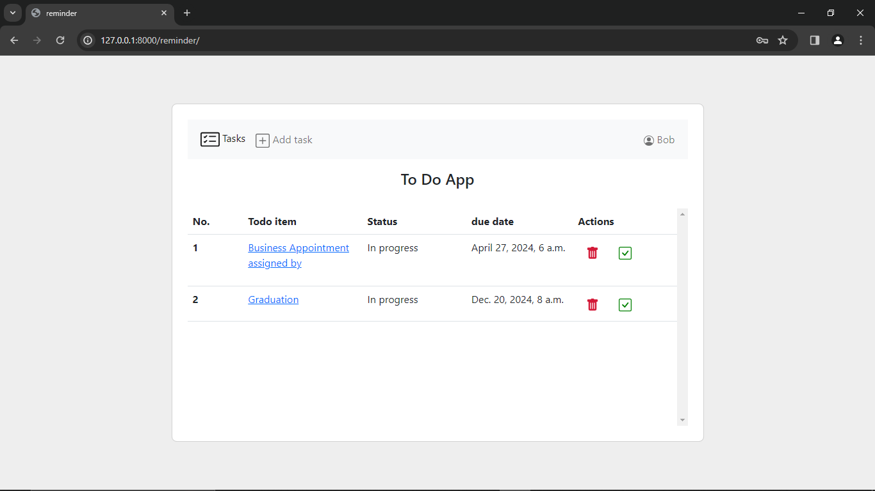

Figure :To-do list homepage.

**Add Task:**

If a user wishes to add a new task he clicks on the add task hyperlink (found on the to-do list homepage) which will direct him to adding task section. Here the user is able to type in the title, description and due time of the task.

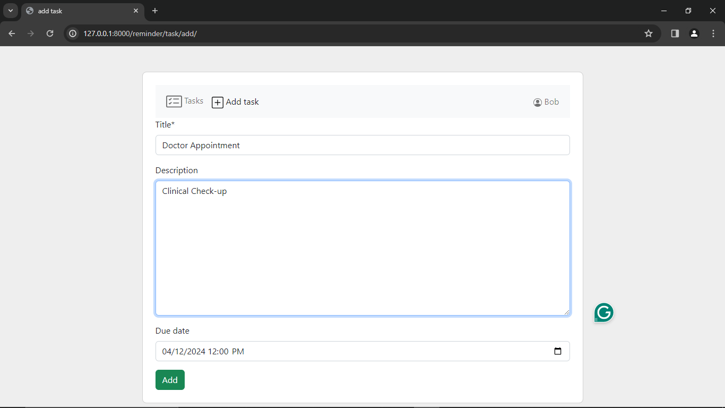

Figure : Adding Task on To-do list

**Update To-Do List:**

If a user wishes to make changes on a task, all he needs to do is click on the already existing task and then proceed to make changes where he wants. Whether it is to change the title, description, due date or even mark an item as completed or notified, this is the section where a user can do that.

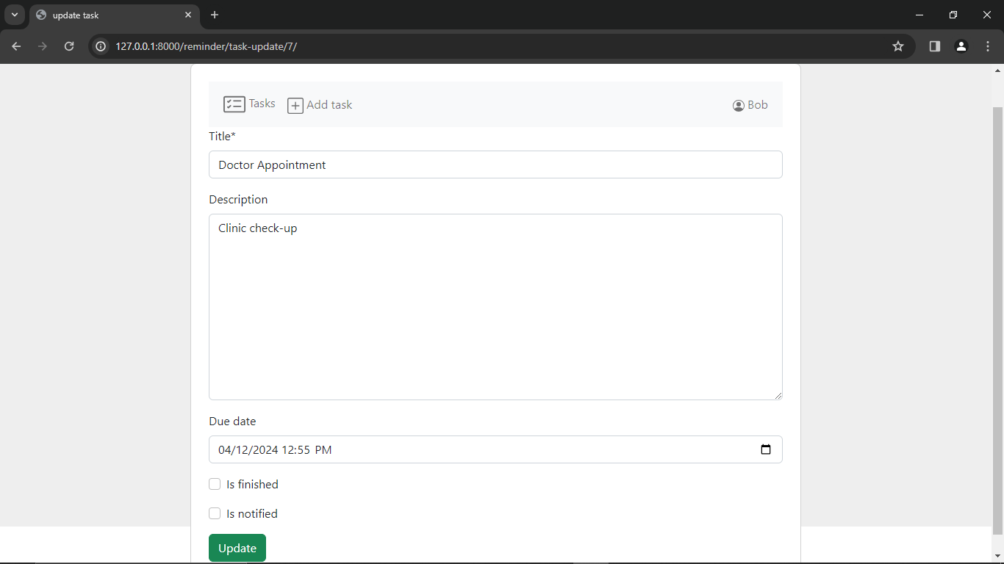

Figure : Update To-Do List

**System Database:**

Django framework was used to develop the back-end web of this e-diary system. If a user faces technical problems, then he can contact the admin who can access the system database and assist them with whichever challenge they are facing. The admin can access every detail of the users that way if they forget their passwords he can change for them passwords, if they are unable to add, view or delete categories and notes the admin is able to solve all these issues.

The admin can also view total number of users and can also change their status from either regular user or staff status and decide on what they can and cannot do with the e-diary system.

The screenshots below show the databse forms and database model code. These data models define the structure and relationships of database tables. Django uses an Object-Relational Mapping (ORM) system, which allows one to define database schema using Python classes and attributes instead of writing SQL queries.

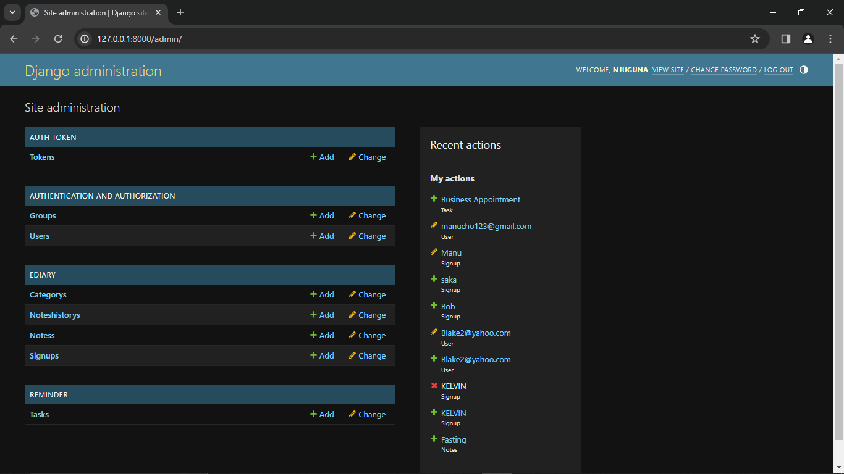

Figure :System Database Form

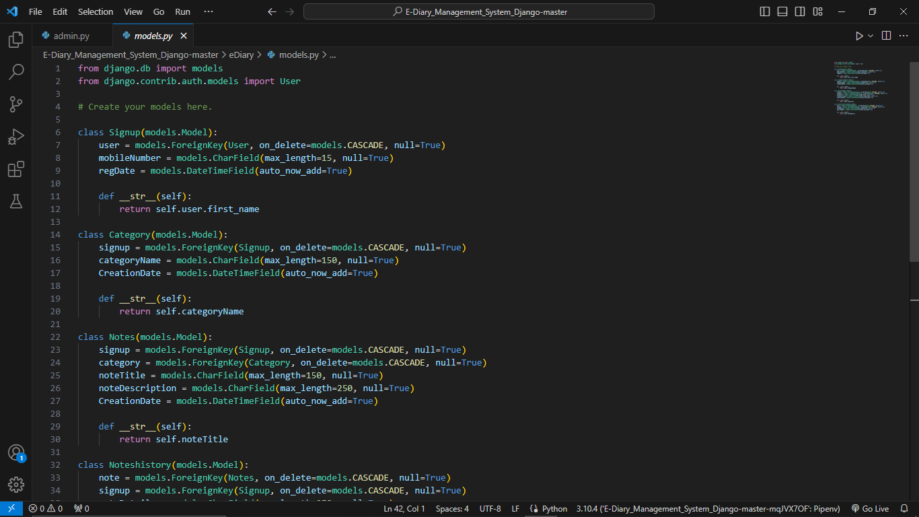

Figure :database model code

## 4.3 SYSTEM TESTING

The system testing phase was an integral part of the software development life cycle for the e-diary application with a to-do list. It encompassed various levels of testing, including unit testing, integration testing, and acceptance testing. This comprehensive approach ensured that the application was robust, reliable, and capable of meeting user expectations.

## 4.3.1 UNIT TESTING

Unit testing was the initial phase of testing and focuses on verifying the correctness of individual components or units, ensuring that each function operated as intended.

|  |  |  |  |
| --- | --- | --- | --- |
| **Test Scenario** | **Test Description** | **Expected Result** | **Status (Pass/Fail)** |
| User Registration | Test registration with valid/invalid data | User accounts created | Pass |
| To-Do List Management | Test create, edit, and delete | Actions performed correctly | Pass |
| User Authentication | Test login with valid/invalid credentials | Successful/failed logins | Pass |

Table : Unit Testing

## 4.3.2 INTEGRAL TESTING

Integration testing verified the interactions between different components and ensured that the integrated system functions as a whole.

|  |  |  |  |
| --- | --- | --- | --- |
| **Test Scenario** | **Test Description** | **Expected Result** | **Status (Pass/Fail)** |
| Data Flow | Test data flow through components | Data properly saved/retrieved | Pass |
| User Interaction | Test interaction between features | Seamless interaction | Pass |
| Security and Data Protection | Test security integration | Data remains secure | Pass |

Table : Integration Testing

4.3.3 ACCEPTANCE TESTING

Acceptance testing validated that the e-diary application met the requirements and expectations of end-users.

|  |  |  |  |
| --- | --- | --- | --- |
| **Test Scenario** | **Test Description** | **Expected Result** | **Actual Result** |
| User Registration | Test the user registration process by creating new user accounts with valid and invalid information. | New user accounts are successfully created when valid data is provided. An error message is displayed for invalid data. | New users were able to successfully create accounts once they provides valid data. |
| User Authentication | Test user login with valid and invalid credentials. | Users can successfully log in with valid credentials. Unsuccessful login attempts with incorrect information result in error messages. | Users who entered wrong credentials were unable to login while those that entered valid credentials succeeded to log in |
| Diary Entry Management | Test the creation, editing, and deletion of diary entries | Diary entries can be added, edited, deleted without errors. | Users were able to add, edit and delete diary entries without errors. |
| Performance and Responsiveness | Test the application's speed and responsiveness under real-world usage scenarios. | The application responds quickly and efficiently, even under high loads. | Users agreed the system was fast in performance and response. |
| Usability and User Experience | Engage real users to evaluate the application's user-friendliness, navigation, and overall user satisfaction. | Users find the application easy to use, navigate, and express overall satisfaction with the user experience. | Users were able to operate the system seamlessly |

Table : Acceptance Testing

# **CHAPTER FIVE**

# **CONCLUSSION AND RECOMMENDATION**

## 5.1 CONCLUSION

I conclude the discussion on the e-diary application with a to-do list project by highlighting the achievements, challenges, and the potential for future developments. This serves as a culmination of the entire project, summarizing the key findings and providing insights into the impact of the application.

The development and testing phases of the e-diary application have demonstrated a significant step forward in creating a digital solution that assists users in organizing their lives, promoting self-reflection, and effectively managing tasks and to-do lists. Throughout the project's lifecycle, I have meticulously planned, designed, and coded the application while subjecting it to rigorous testing to ensure its reliability and robustness.

**Key Achievements:**

1. **Comprehensive Functionality:** The e-diary application offers a user-friendly interface for creating diary entries, managing to-do lists, and attaching multimedia content, fostering an all-in-one solution for users.
2. **Testing and Quality Assurance:** The project underwent meticulous unit testing, integration testing, and acceptance testing. These phases ensured that the application functions correctly, integrates seamlessly, and meets user expectations.
3. **User-Centered Approach:** The involvement of real end-users in the acceptance testing phase enabled us to align the application with user requirements and preferences, resulting in a more user-centric product.
4. **Security and Privacy:** The application includes security features to protect user data and ensure privacy, instilling confidence in users regarding the safety of their information.

## 5.2 RECOMMENDATION

While the project has achieved a significant milestone, the e-diary application with a to-do list offers ample room for future development and improvement. Several areas can be explored for further enhancements and refinements:

1. **Advanced Features:** Consider the addition of advanced features, such as goal tracking, and notification systems, to provide users with a more comprehensive organizational tool.
2. **Data Analytics:** Implement data analytics capabilities to offer users insights into their behavior, emotions, and task management patterns, facilitating deeper self-reflection and personal growth.
3. **Cross-Platform Support:** Extend the application's availability to various platforms, including mobile devices (iOS and Android) and desktop applications, to accommodate a broader user base.
4. **Data Synchronization and Backup:** Develop features for data synchronization and backup to ensure users never lose their valuable diary entries and to-do lists, even in the event of device changes or data loss.
5. **Security and Privacy Enhancement:** Continuously enhance security measures and privacy features to safeguard user data and maintain users' trust in the application.
6. **Performance Optimization:** Continuously monitor and optimize the application's performance to maintain its responsiveness, even as the user base grows.
7. **Community Building:** Establish a user community or support platform for users to share their experiences, tips, and suggestions, fostering a sense of belonging and mutual assistance among users.
8. **Internationalization and Localization:** Consider making the application available in multiple languages to cater to a global user base, broadening the application's accessibility.

## 5.3 SUMMARY

The e-diary application with a to-do list represents a significant achievement in the realm of digital tools aimed at aiding users in their daily lives. With ongoing development and thoughtful enhancements, it has the potential to become an indispensable companion for users, helping them manage their daily tasks, reflect on their experiences, and achieve their goals. The journey towards improvement and innovation in this digital space promises to be both exciting and fulfilling, offering the prospect of a meaningful impact on users' personal and professional lives. As I conclude this chapter, I look forward to the promising future of the e-diary application and its continued evolution.

## REFERENCES

* Baikie, K. A., & Wilhelm, K. (2005). Emotional and physical health benefits of expressive writing. “Advances in Psychiatric Treatment, Vol11(5), PP 338-346.
* Pennebaker, J. W., & Seagal, J. D. (1999). Forming a story: The health benefits of narrative. *Journal of Clinical Psychology*, Vol55(10), PP 1243-1254.
* Daniëls, N. E. M., Hochstenbach, L. M. J., van Zelst, C., van Bokhoven, M. A., Delespaul, P. A. E. G., & Beurskens, A. J. H. M. (2021). “Factors That Influence the Use of Electronic Diaries in Health Care: Scoping Review”. JMIR mHealth and uHealth, Vol9(6), PP19536.
* BMC Medical Research Methodology. (2021). “A qualitative approach to guide choices for designing a diary study”. British Medical Center Medical Research Methodology, Vol18, PP 140.
* Shiffman, S., Stone, A. A., & Hufford, M. R. (2008). “Ecological momentary assessment”. *Annual Review of Clinical Psychology*, Vol4, PP1-32.
* Yan, Z., Chiu, M. M., & Ko, P. Y. (2020). “Effects of self-assessment diaries on academic achievement, self-regulation, and motivation”. *Assessment in Education: Principles, Policy & Practice*, Vol*27*(5), PP 562–583.
* Tiplady, B., Crompton, G. K., & Brackenridge, D. (1995). “Electronic diaries for asthma”. *British Medical Journal (Clinical research ed.)*, Vol*310*(6992), PP 1469.
* Bolton, R. N., Parasuraman, A., Hoefnagels, N., Migchels, N., Kabadayi, S., Gruber, T., ... & Solnet, D. (2013). “Understanding generation Y and their use of social media: A review and research agenda”. *Journal of Service Management*, Vol.24(3), PP.245-267.
* Stone, A. A., Shiffman, S., Schwartz, J. E., Broderick, J. E., & Hufford, M. R. (2003). Patient non-compliance with paper diaries. British Medical Journal, Vol.324(7347), PP1193.

## APPENDICES

## Appendix I: Research Instruments

1. Survey questionnaire for participants
2. Interview guide for key informants

## Appendix II: Work Plan

|  |  |
| --- | --- |
| **Task** | **Duration (in weeks)** |
| Literature Review | 2 |
| Develop Research Framework | 1 |
| Data Collection | 4 |
| Data Analysis | 3 |
| Report Writing | 3 |
| Total | 13 |

## Appendix III: Budget

|  |  |
| --- | --- |
| **Item** | **Estimated Cost (Ksh)** |
| Research Assistants | 5,000 |
| Transportation | 3,000 |
| Stationery and Printing | 700 |
| Communication | 300 |
| Software and Technology | 40,000 |
| Contingencies | 1,000 |
| Total | 50,000 |